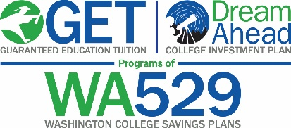

Suggested Content for Employer Communications/Newsletters
Below are a few suggested articles you are free to use in your organization’s newsletter, intranet or email communication with employees to help them learn more about the Washington 529 Plans.

20-words
Learn about Washington’s 529 College Savings Plans (WA529), the Guaranteed Education Tuition Program and DreamAhead College Investment Plan at wastate529.wa.gov

30-words
Washington’s 529 College Savings Plans (WA529) help families save for education expenses. With tax benefits, flexible contribution options and worldwide choice of schools, it’s easy to start saving today. wastate529.wa.gov

50 -words
Washington’s 529 College Savings Plans (WA529) – the Guaranteed Education Tuition Program and DreamAhead College Investment Plan, are designed to help families save for a variety of education expenses. With tax benefits, flexible contribution options and worldwide choice of schools, it’s easy to start saving today. Learn more at wastate529.wa.gov

60 – words
The Washington 529 College Savings Plans (WA529), which include the Guaranteed Education Tuition (GET) Program and DreamAhead College Investment Plan, are designed to help families save for their children or grandchildren’s future college and career training expenses. With tax benefits, flexible contribution options and worldwide choice of schools, it’s easy to help families start saving today. Learn more at wastate529.wa.gov

Please contact the WA529 Community Relations Manager at 360.485.1198 or WA529Outreach@wsac.wa.gov
if you have any questions or comments about this content.
July 2021

